SIMATS ENGINEERING
ASSESSMENT TOOL 2

COURSE NAME: Ethical Hacking COURSE CODE: ITA14

Social Engineering Simulation

Code of Conduct:
I M Dhruthika (192572020) certify that this submission is my original work and that I have adhered to the guidelines specified for this assessment.I understand that any violation of academic integrity rules will result in disciplinary action.

1. As a Security Analyst, perform an OSINT-based email enumeration assessment on the target domain tesla.com using theHarvester in Kali Linux. Collect publicly available email addresses,subdomains, hosts, and IP addresses associated with the organization. Categorize the discovered email addresses into likely roles such as Support, Sales, Human Resources, Administration, and Technical Teams. Analyze how the gathered information could assist an attacker during the reconnaissance phase and explain how it could be used for spear-phishing, credential harvesting, and impersonation attacks. Finally, recommend at least five countermeasures to reduce information leakage and social engineering risks, and submit a report with screenshots, commands executed,findings, risk analysis, and recommendations.

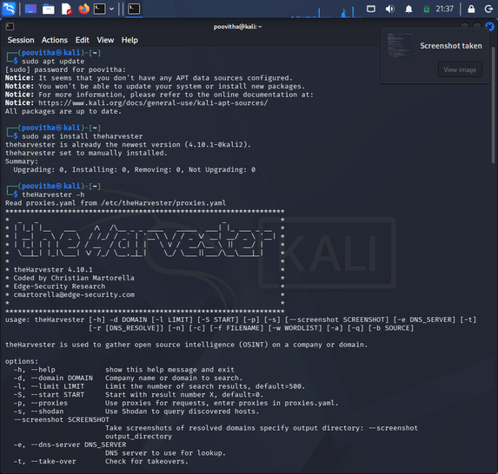

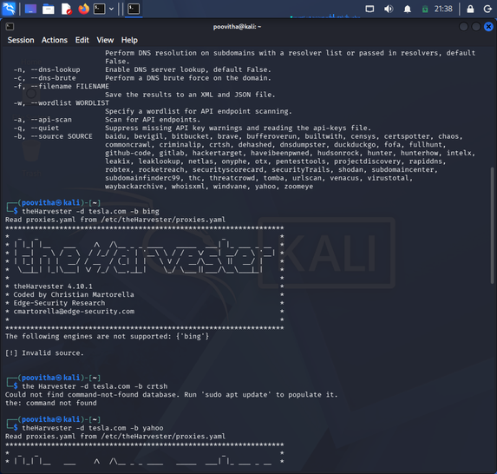

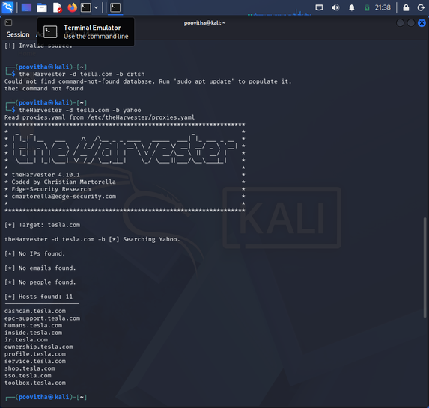

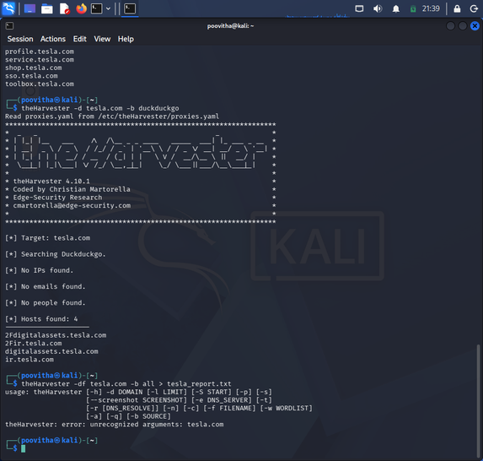

2.As a cybersecurity awareness consultant, you are required to conduct a phishing awareness simulation using GoPhish and dummy employee accounts provided in the lab. Create an email template, launch a campaign, monitor user interactions, and generate a report showing delivery rate,email open rate, and click rate. Based on the results, provide recommendations to improve user awareness against phishing attacks.

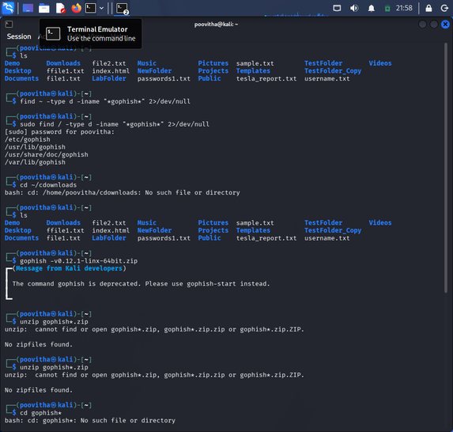

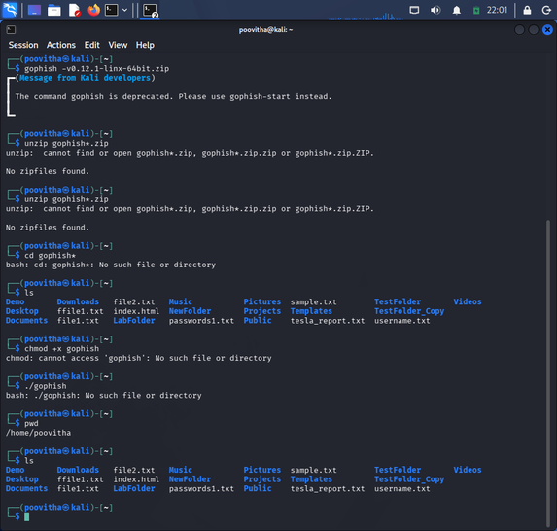

3. Using Nmap Aggressive Scan (-A) on scanme.nmap.org, gather detailed information about the target including operating system details, open ports, and service versions. Assume you are an attacker and describe how the collected information could be leveraged to conduct a social engineering attack against the IT support team. Prepare a report explaining the attack methodology and defensive recommendations.

